

GDGS Zebra Tables
Browser Consistency Check

Document Version
0.1

Last Updated
3/7/2011 11:26:42 AM

Prepared by
User Interface Team

OS X 10.5 Browsers
- Firefox 3.6.x renders like Windows Firefox 3.6.x.
- Chrome 9.x renders like Windows Chrome 9.x except for <th> borders which render like Firefox 3.6.x.
- Shiira 2.3 renders like Windows Chrome 9.x.
- Safari 5.x renders like Windows Chrome 9.x except for <caption> which is slightly shifted to the left right.
- Opera renders similarly across both OSs.

Windows XP Browsers
Opera 11.X
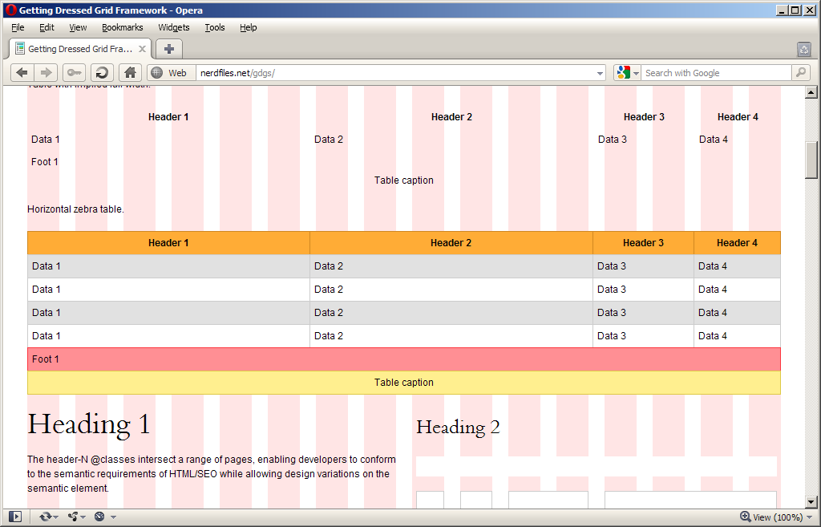

Chrome 9.x
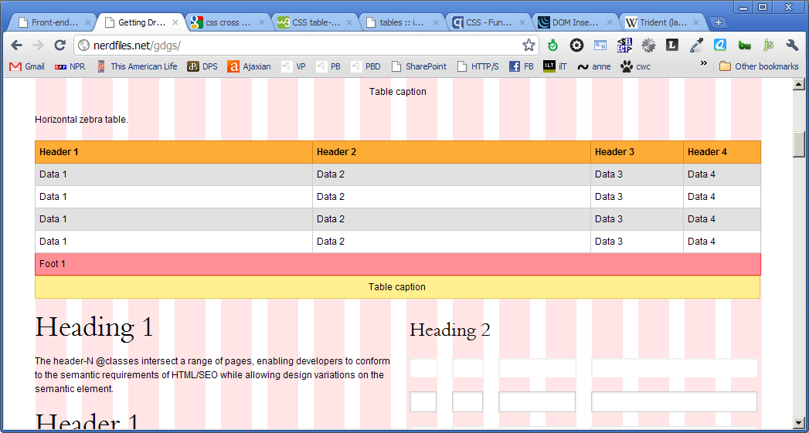

IE7 (IE8 Compatibility Mode):
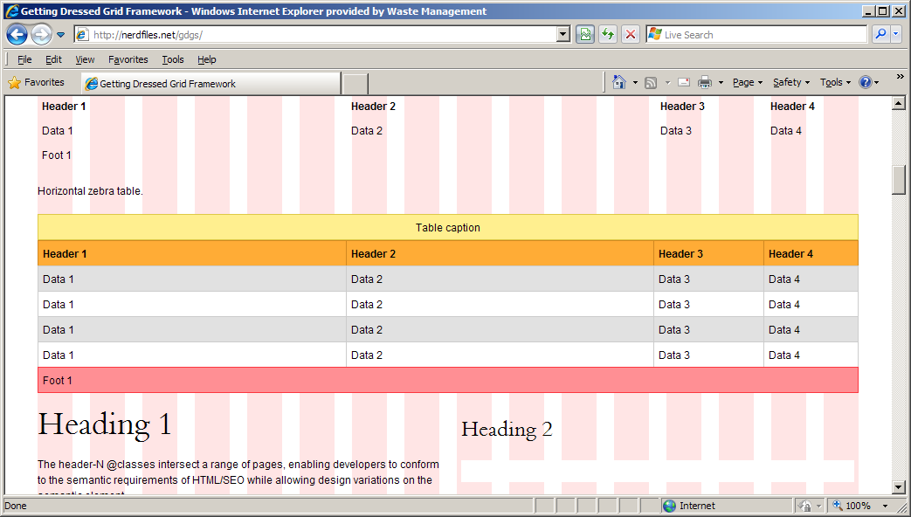

IE8:
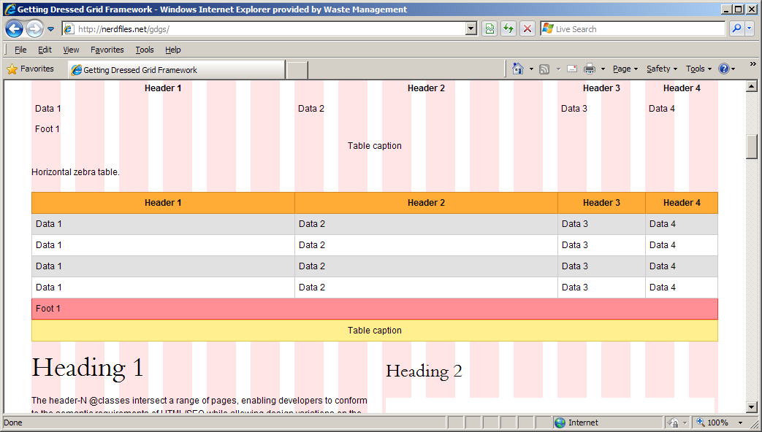

Firefox 3.6.x:
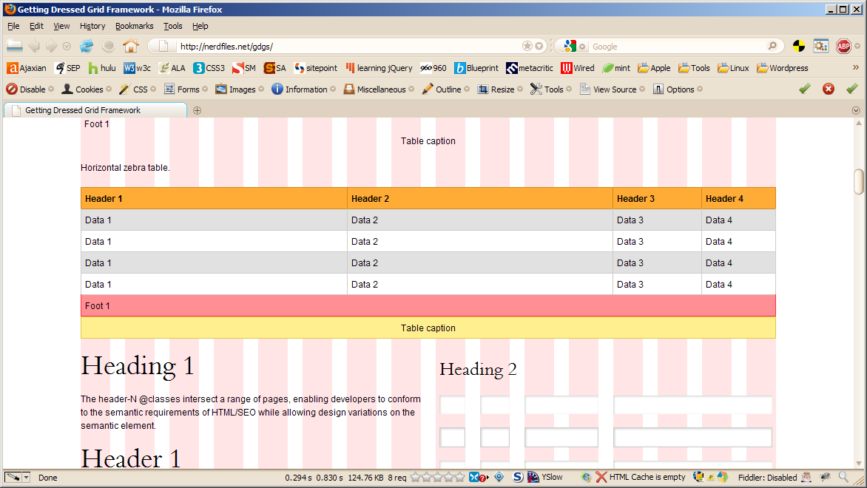

Firefox 4.0 beta 1:
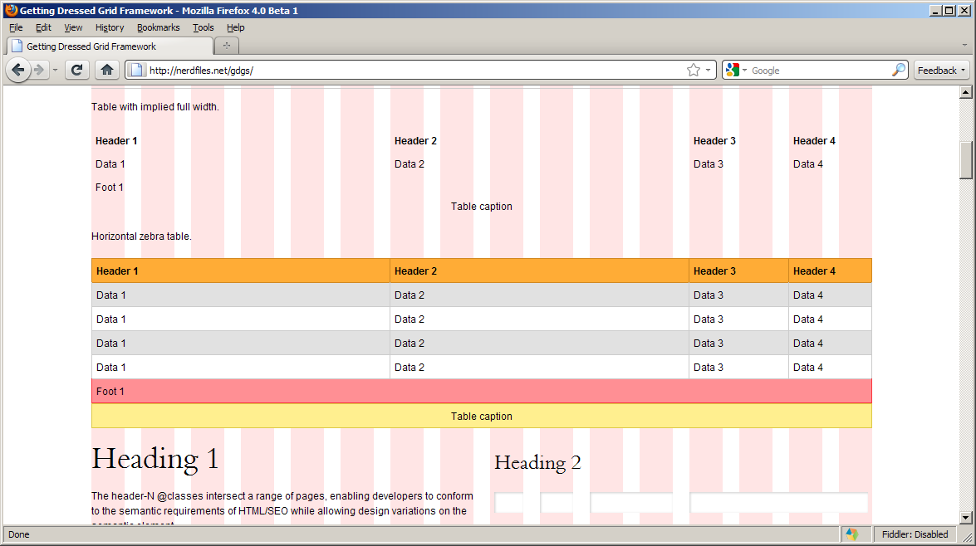

Safari 5.x:
